Session 20

|  |
| --- |
| **Objectives**  The goals of this session |
| 1. Continue random tree activity (focus activity 1) 2. Recap loops 3. Percentages in randomness |

|  |
| --- |
| **Method Focuses**  New methods or functions that you will learn during this session |
| No new methods |
| **Property Focuses**  Properties (variables) of classes you will learn during this session |
| No new properties |
| **Documentation Links** |
| Random class  <https://docs.unity3d.com/ScriptReference/Random.html> |

## Focus Activity 1

**Goal**

Create a platform and have trees randomly spawn on that platform.

This will require knowledge of:

* Spawning prefabs
* Making random numbers
* Loops
* Changing the position of an object
* Creating materials

The outcome should look like this:

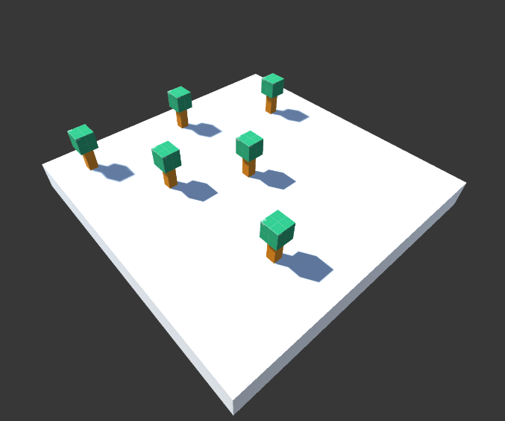

|  |  |
| --- | --- |
| **Session Information**  You can ignore this | |
| **Planned Information** | |
| Session Time Session Date | 5:00PM – 6:00PM AWST 9 February 2021 |
| **Real Information** | |
| Session Time Session Date | 5:03 PM – 6:06PM AWST 9 February 2021 |
| Github Name | Session20Examples |
| Session Length | 1 hour 3 Minutes |
| Activities Completed | |  |  | | --- | --- | | □ | Start Focus Activity 1 | |
| Signature | ____________________________________________  *By signing this you confirm that the session has occurred and the subjects that have been taught have been allocated on this document.* |